SS BUG DESCRPTION Version 1.8(29-01-2025)  
  
  
1. Dash Board Scenario   
  
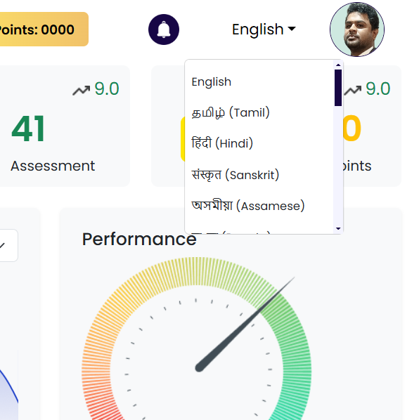  
  
  
Enable English option alone to click. There is no select function performing. Enable select option for particular language, as of now English is mandatory so give select for English.

|  |  |  |  |  |
| --- | --- | --- | --- | --- |
| Module | Sub Module | Bug Created By | Bug Resolved By | Remarks |
| Dash Board | language | Vigneshwar CR |  |  |
|  |  |  |  |  |

2.Dash Board – Login activity  
  
  
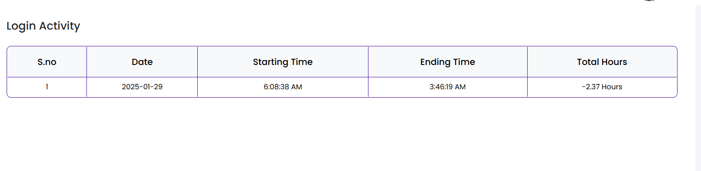  
  
Update the Total Hours value as correctly   
  
Incorrect format: -2.37Hours   
correct format: 2.37Hours

|  |  |  |  |  |
| --- | --- | --- | --- | --- |
| Module | Sub Module | Bug Created By | Bug Resolved By | Remarks |
| Dash Board | language | Vigneshwar CR |  |  |
|  |  |  |  |  |

3. DashBoard -After Login   
  
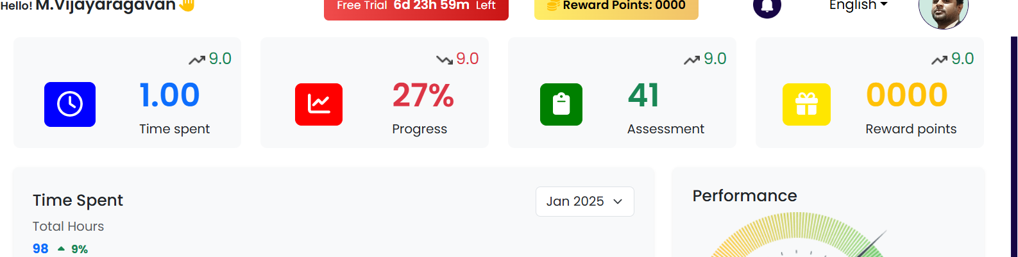  
  
After successful login into SS App, Some Glitch image is displaying below user name , Vijayaragavan below .Check and remove that image .

|  |  |  |  |  |
| --- | --- | --- | --- | --- |
| Module | Sub Module | Bug Created By | Bug Resolved By | Remarks |
| Dash Board | language | Vigneshwar CR |  |  |
|  |  |  |  |  |

4.DashBoard -My Learning Section  
  
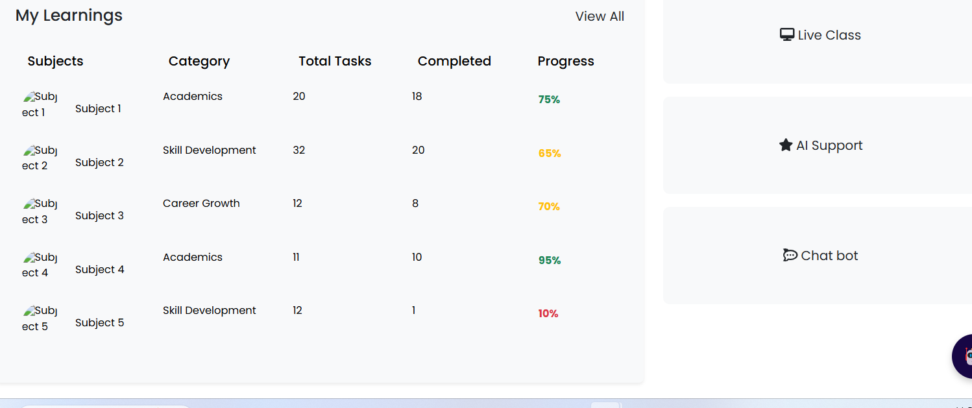  
  
Image was not displaying properly in the Subjects list, So check and update properly with clear displaying image.

|  |  |  |  |  |
| --- | --- | --- | --- | --- |
| Module | Sub Module | Bug Created By | Bug Resolved By | Remarks |
| Dash Board | My Learning | Vigneshwar CR |  |  |
|  |  |  |  |  |

5. Dash Board – Chat Bot   
  
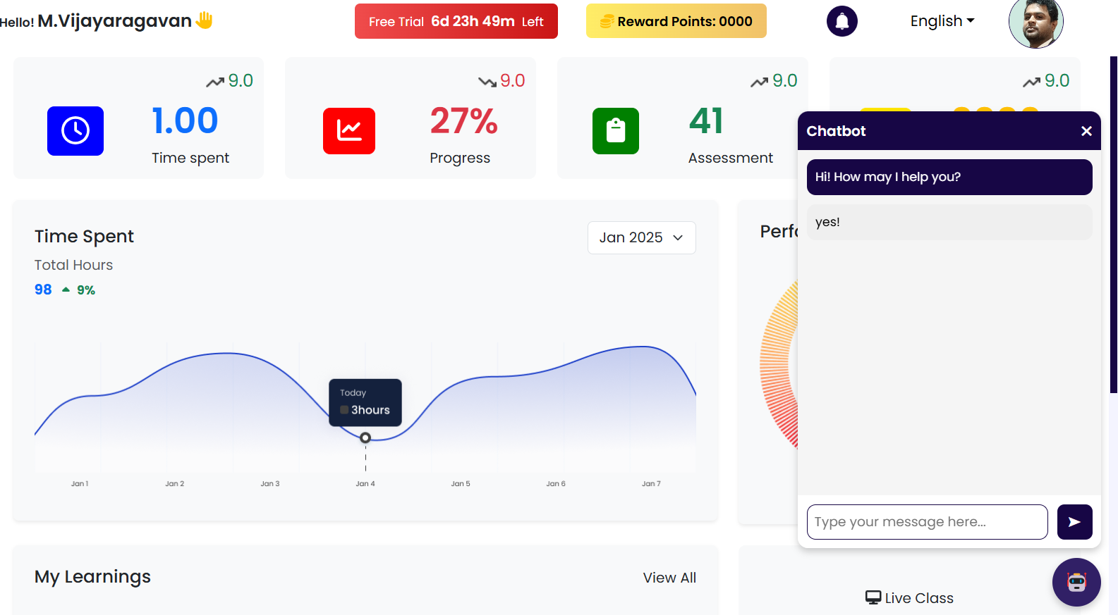  
  
Chat Bot Function Correctly working in the Dashboard Page, But in Remaining Pages Chat Function Not working. Check all the displayed pages that chat Bot function working properly displaying image as above.  
  
  
Enable Chat Bot click Function In all the pages as same as Dashboard page .  
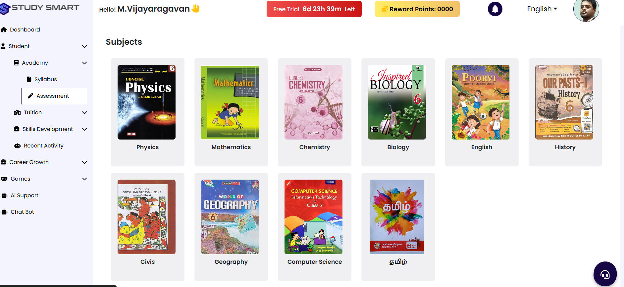

|  |  |  |  |  |
| --- | --- | --- | --- | --- |
| Module | Sub Module | Bug Created By | Bug Resolved By | Remarks |
| Dash Board | Chat Bot | Vigneshwar CR |  |  |
|  |  |  |  |  |
|  |  |  |  |  |

6.Dash Board -Time Spend   
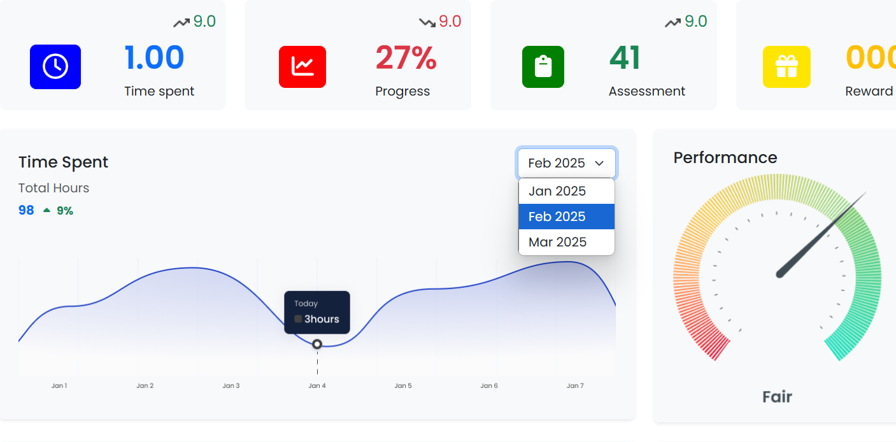  
  
While clicking on the Dropdown in Time spent field, If its Feb 2025 and Mar 2025 , The graph should be change as dummy data behaviour .

|  |  |  |  |  |
| --- | --- | --- | --- | --- |
| Module | Sub Module | Bug Created By | Bug Resolved By | Remarks |
| Dash Board | Chat Bot | Vigneshwar CR |  |  |
|  |  |  |  |  |
|  |  |  |  |  |

7.Register -Email Address Field  
  
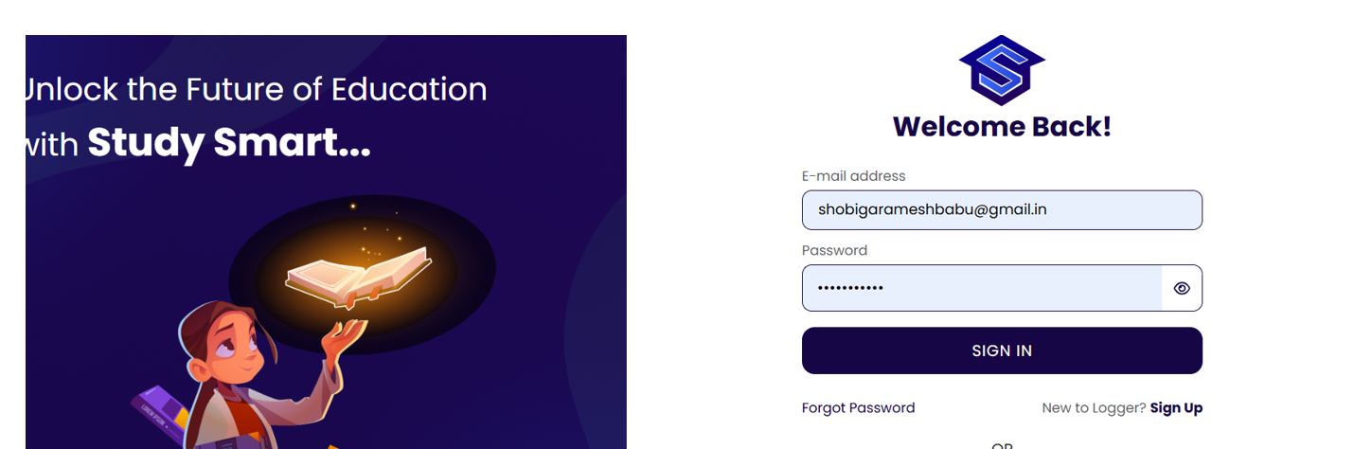  
  
  
While using @gmail.in its accepting, Check and update it for validation.

8. Students -Academy-Syllabus

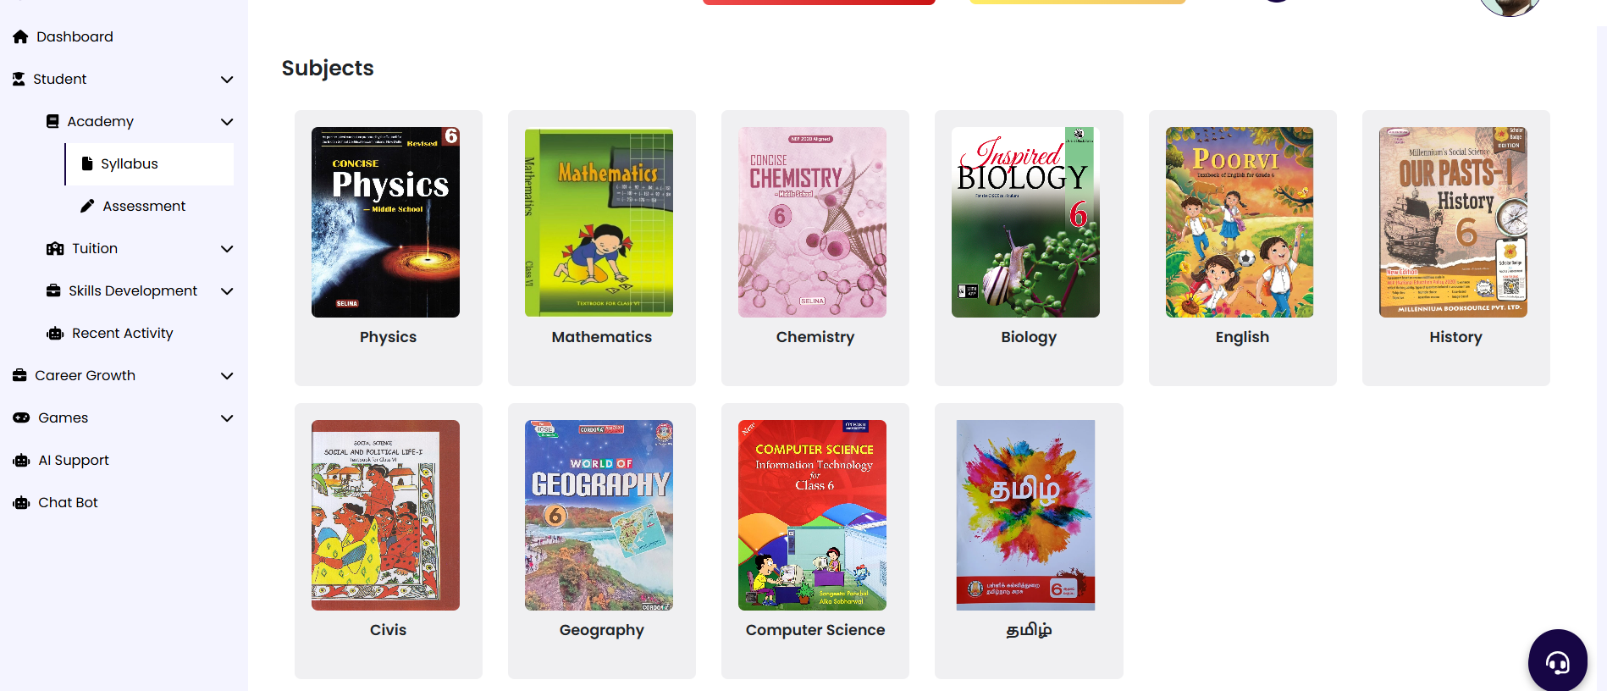  
Correct form of the subject list is Tamil, English, Mathematics, Physics, Chemistry, Biology, History, Civics, Geography, Computer science.  
  
9. Forgot Password   
  
  
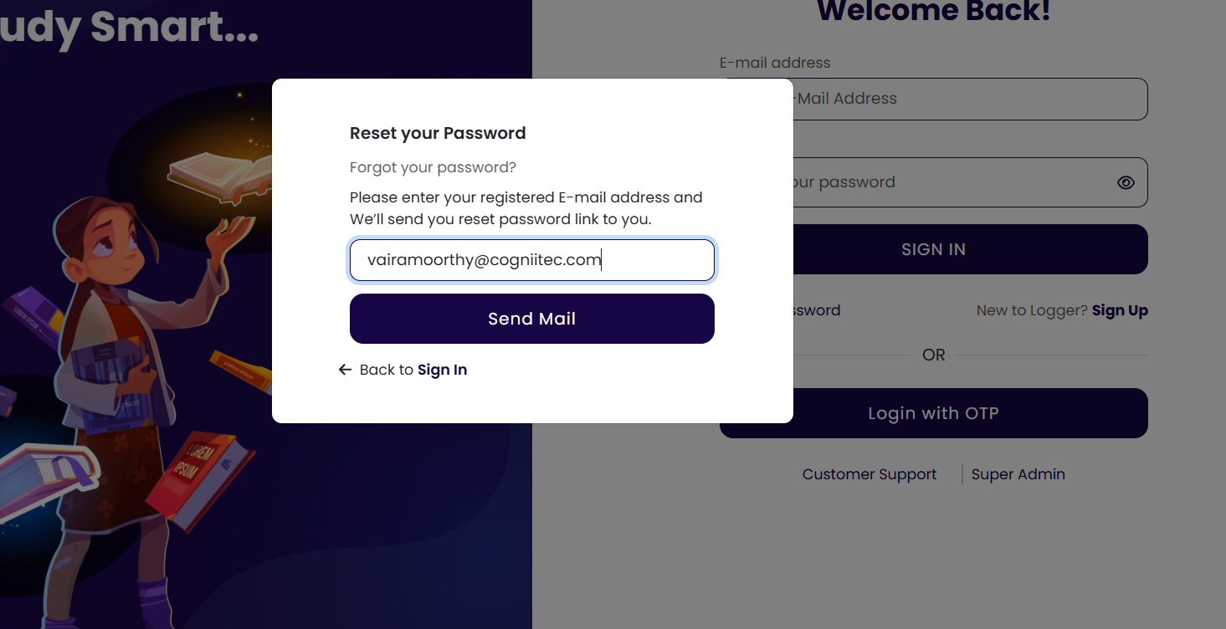  
  
  
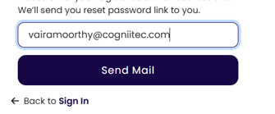  
  
correct format of the forgot password click button is Send Mail .  
  
  
  
  
  
  
  
  
  
  
  
  
  
  
  
  
  
Below its showing wrong , when I use the forgot scenario for multiple times its showing wrong in below image .  
  
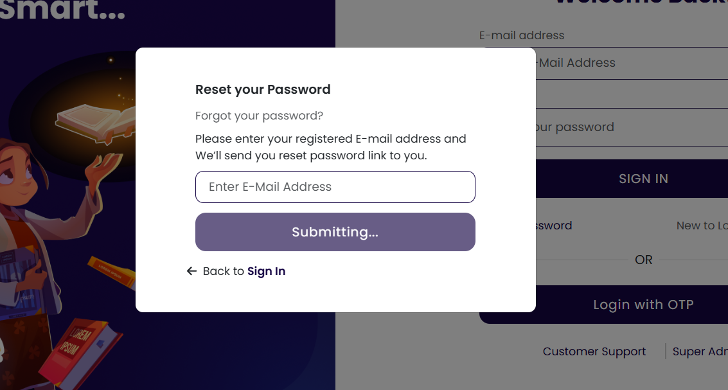

|  |  |  |  |  |
| --- | --- | --- | --- | --- |
| Module | Sub Module | Bug Created By | Bug Resolved By | Remarks |
| Forgot Password | Forgot Password | Vigneshwar CR |  |  |
|  |  |  |  |  |

